Simulation Design- Wine Production

# Step 1: Grape Harvesting

State Definitions for Grape Harvesting

* HG: Harvesting Grapes
* NH: Not Harvesting Grapes

Grapes are harvested exclusively in September because, during other months, the grapes can become overripe and potentially sour, which adversely affects wine quality. It's crucial to harvest at the correct time to ensure the best wine production, which in this scenario, is September.

## Steps for the Grape Harvesting Process

* Begin in the NH (Not Harvesting) state.
* In September, prepare both red and white grape varieties for harvesting.
* Once September, the ideal harvesting month, arrives:
  + Shift state to HG (Harvesting Grapes).
  + Allocate a one-month period for harvesting.
* After the harvest is complete, revert to the NH state and wait for the next optimal harvesting month, which is 11 months later.

# Step 2: Transportation from Wine Harvesting Field to Wine Factory

The Transportation process happens every October when the grapes are harvested. The Bonded Transportation transports the grapes to the factory where the grapes are ready for the wine production process.

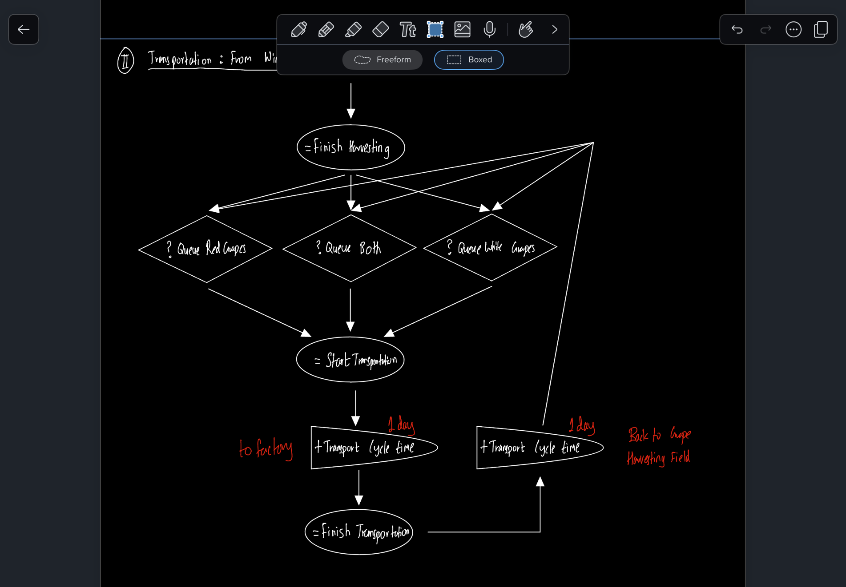

# Step 3: Factory Wine Production

The production phase in the winery involves the transformation of red and white grape varieties into wine.

This phase is structured into two distinct simulations:

1. Simulation 1 focuses on producing less expensive red and white wines:
   1. This approach expedites the wine production process, allowing for quicker service to customers.
   2. Wines
      1. Red Wine 1: Pinot Noir Ler Cru, 125 Euros
      2. White Wine 1: Chardonnay Ler Cru, 90 Euros
2. Simulation 2 is geared towards crafting both affordable and premium red and white wines:
   1. Wines aged in oak for longer periods may take an additional year or two to produce compared to their less expensive counterparts. However, this method may be more profitable over time, as it allows for charging higher prices.
   2. Selective handpicking of grapes is common in wineries for the higher-priced wines, which can potentially increase profit margins as opposed to utilizing all harvested grapes for the lower-priced wines from Simulation 1.
   3. Wines
      1. Red Wine 1: Pinot Noir Ler Cru, 125 Euros
      2. White Wine 1: Chardonnay Ler Cru, 260 Euros
      3. Red Wine 1: Pinot Noir Grand Cru, 90 Euros
      4. White Wine 1: Chardonnay Grand Cru, 200 Euros

## Steps for Wine Production Process

1. Upon the grapes' arrival at the winery, it's imperative to verify the availability of sufficient Oak Barrels to commence wine production. Based on our Backtracking Analysis, the requisite number of Oak Barrels has been determined as follows:
   1. Constant Demand: Simulation 1: 3849 Oak Barrels
   2. Constant Demand: Simulation 2: 4037 Oak Barrels
   3. Linear Demand: Simulation 1: 2463 Oak Barrels in Year 1, 3810 Oak Barrels in Year 2, 3947 Oak Barrels in Year 3, etc.
   4. Linear Demand: Simulation 2: 2487 Oak Barrels in Year 1, 4223 Oak Barrels in Year 2, 4759 Oak Barrels in Year 3, etc.
2. Once the required number of Oak Barrels is confirmed to be available, proceed with the wine production process.
3. The Time Taken for Each Wine Production is
   1. Red Wine 1: Pinot Noir 1er Cru
      1. Crushing and Destemming - 3 hours
      2. Maceration - 4 weeks
      3. Alcoholic Fermentation - 2 weeks
      4. Pressing - 4 hours
      5. Malolactic Fermentation - 2 months
      6. Oak Aging - 15 months
      7. Clarification and Fining - 5 days
      8. Filtration - 3 hours
      9. Bottling - 1/2 day
   2. Red Wine 2: Pinot Noir Grand Cru
      1. Crushing and Destemming - 3 hours
      2. Maceration - 4 weeks
      3. Alcoholic Fermentation - 2 weeks
      4. Pressing - 4 hours
      5. Malolactic Fermentation - 2 months
      6. Oak Aging - 24 months
      7. Clarification and Fining - 5 days
      8. Filtration - 3 hours
      9. Bottling - 1/4 day
   3. White Wine 1: Chardonnay 1er Cru
      1. Crushing and Destemming - 3 hours
      2. Pressing - 4 hours
      3. Alcoholic Fermentation - 2 weeks
      4. Malolactic Fermentation - 2 months
      5. Oak Aging - (Not specified, step crossed out)
      6. Clarification and Fining - 5 days
      7. Bottling - 1/2 day
   4. White Wine 2: Chardonnay Grand Cru
      1. Crushing and Destemming - 3 hours
      2. Pressing - 4 hours
      3. Alcoholic Fermentation - 2 weeks
      4. Malolactic Fermentation - 2 months
      5. Oak Aging - 12 months
      6. Clarification and Fining - 5 days
      7. Bottling - 1/4 day
4. End Production of the Respective Wines and Store them in the Winery Warehouse

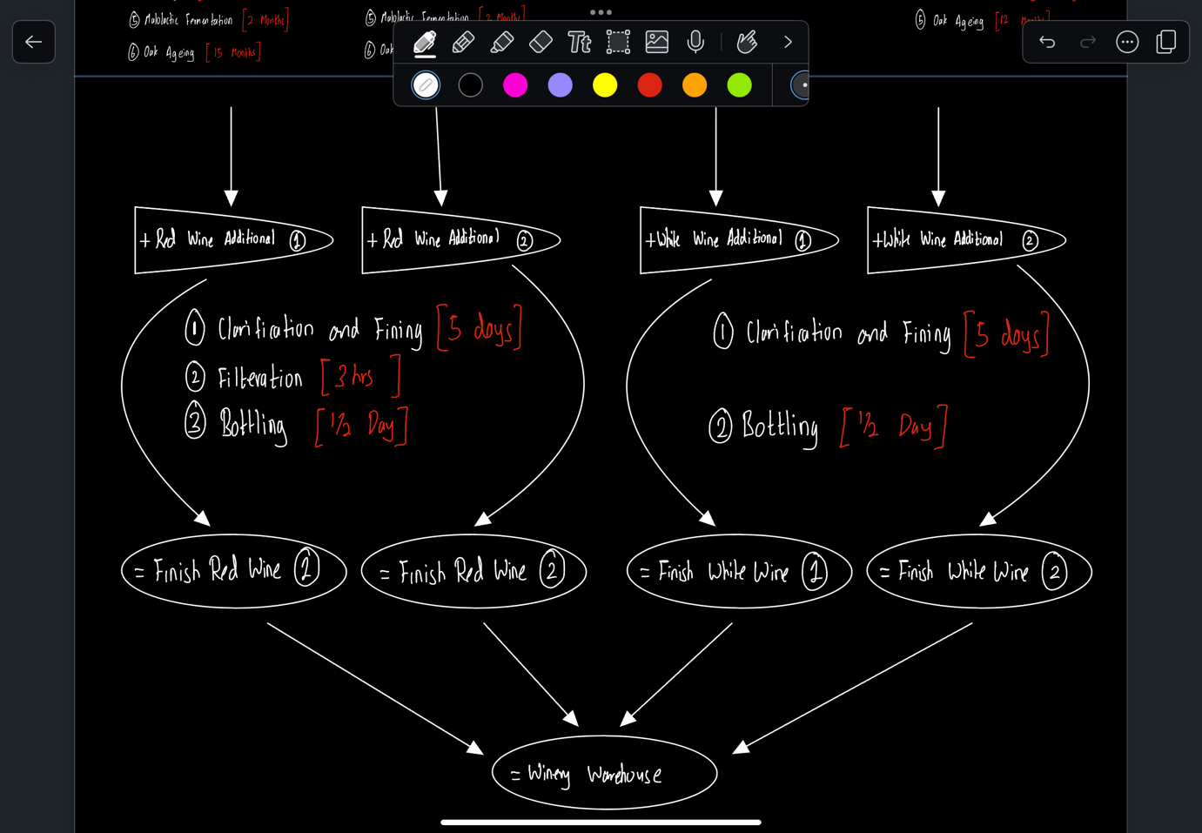

# Step 4: Transportation from Winery Warehouse to Local Bonded Warehouse

This step covers the logistics of moving wine from the winery's warehouse to local bonded warehouses located in five different countries: Singapore, Thailand, Japan, Korea, and Indonesia. From these warehouses, wine is further distributed to wine shops as needed, a practice that aligns with manufacturing and operations management principles, particularly those related to maintaining stock levels and managing reorders.

## Steps for Transportation

1. Begin the process at the winery's warehouse.
2. Monitor inventory levels at each local bonded warehouse; place new orders when stock falls below the predetermined threshold.
3. Ensure there is at least one ship at the shipping dock, ready to transport the wine to the destination country.
4. After the ship reaches the destination country, arrange for a transportation truck to deliver the wine to the local bonded warehouse.
5. The local bonded warehouse will hold the wine inventory until the wine shops in the respective countries place orders based on their demand for wine.

